

*Asp.net Project 2018-2019*

*Öğr. Gör. SAJAD EINY*

*Mhd Omar Bahra*

*B1605.090065*

**Use Case Scenario:**

If the user tries to access the website through any link he will be redirected to the log in page, so only admins can access the control panel, after that the user will be asked to log in or register if he doesn’t have an account. After login in the admin will see a list of customers with their data on the screen and three buttons update delete and insert.

If the user presses on insert he will be able to insert a new rent to a specific customer.

If the user presses on update he will be able to update a specific rent by its Id.

If the user presses on delete a modal page will pop up and he will be able to delete a specific rent by its Id.

On the right the admin is able to view his profile and update it and he is able to log out as well.

**Use Case DIAGRAM:**

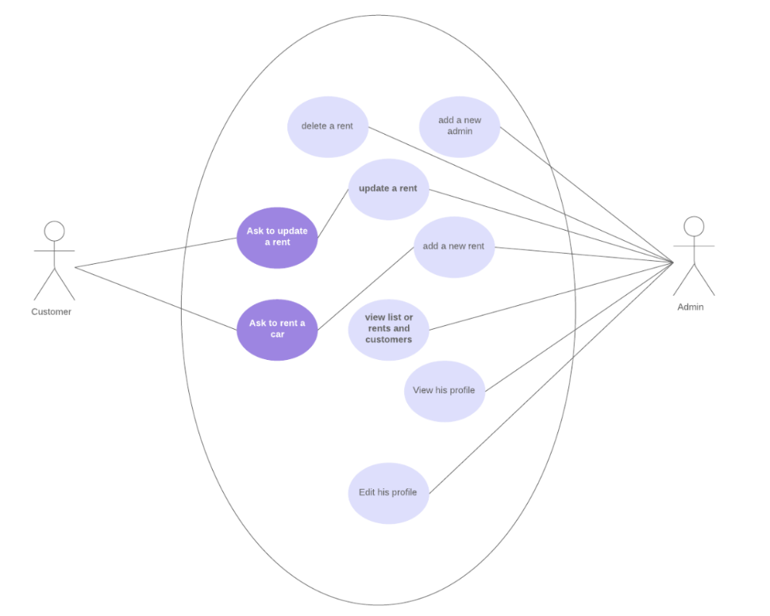

**UML CLASS DIAGRAM:**

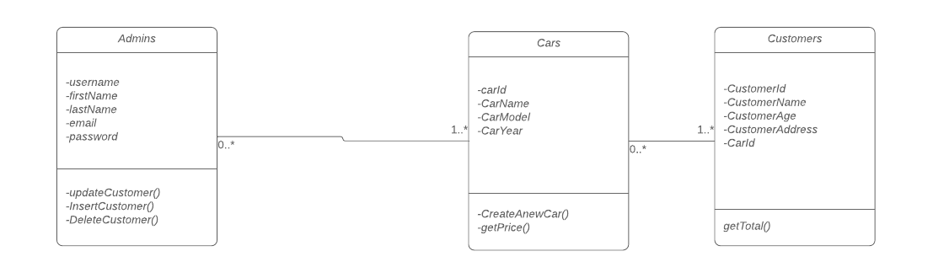

**Database Diagram:**

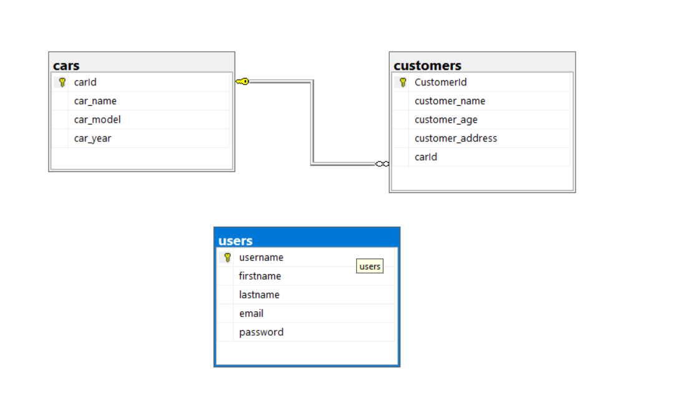

**Domain Diagram(conceptual Diagram):**

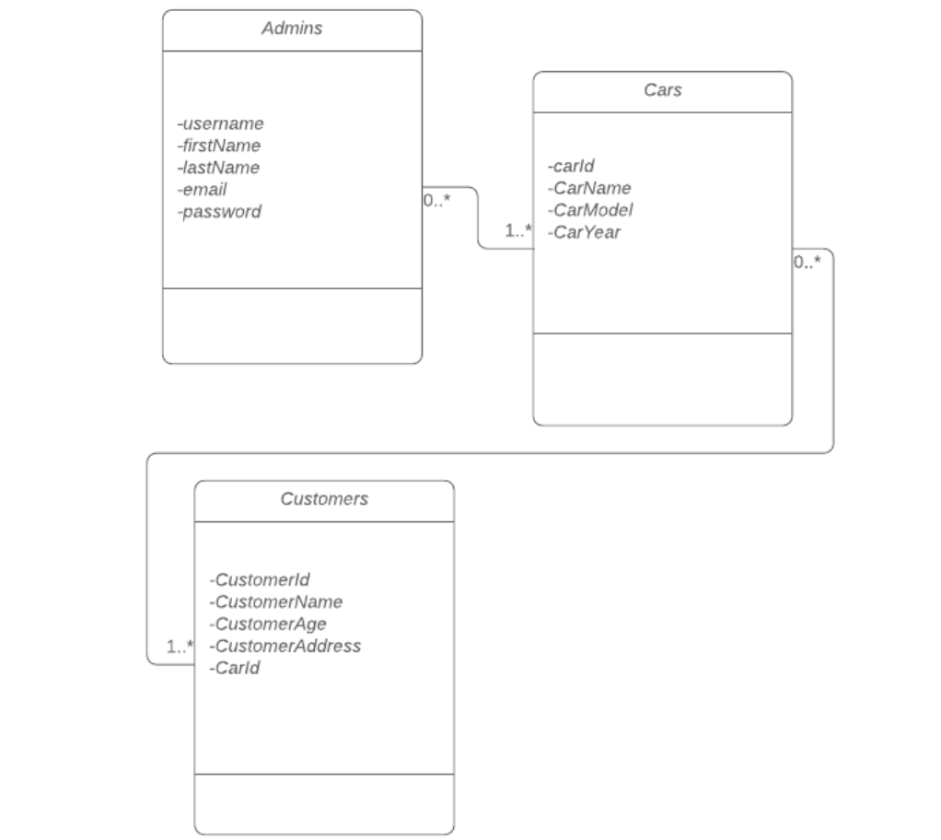

**Activity Diagram:**

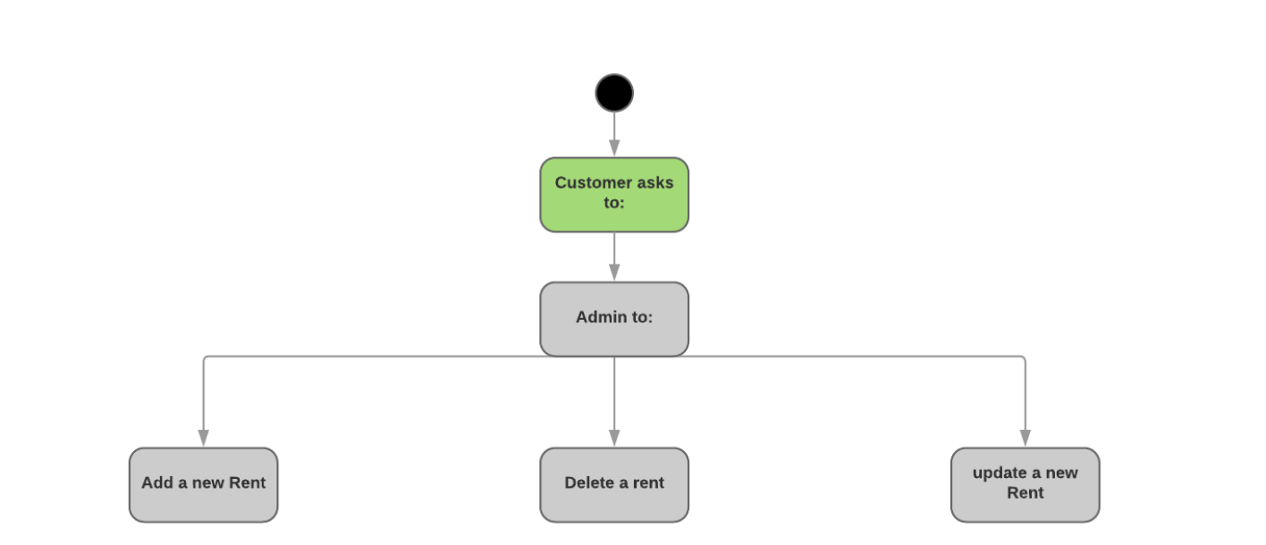

**State Diagram:**

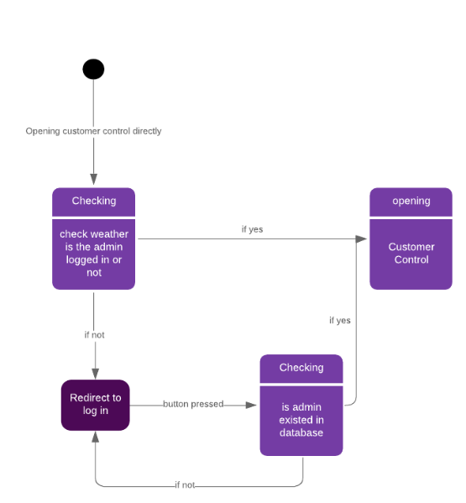

**Register Page Client Side:(Html &css Side with some asp.net)**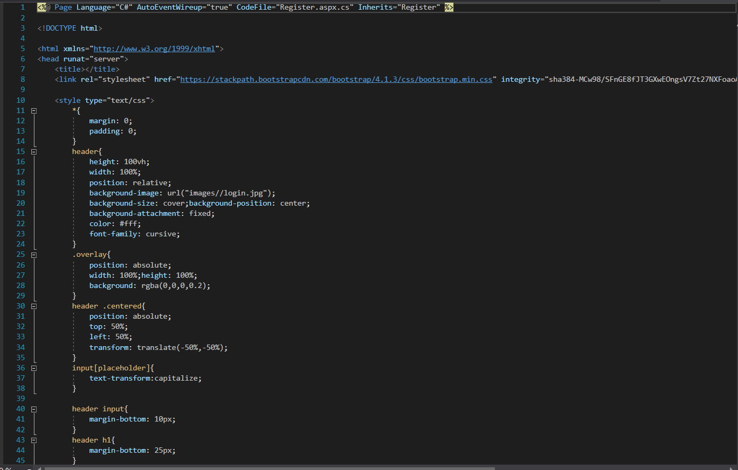 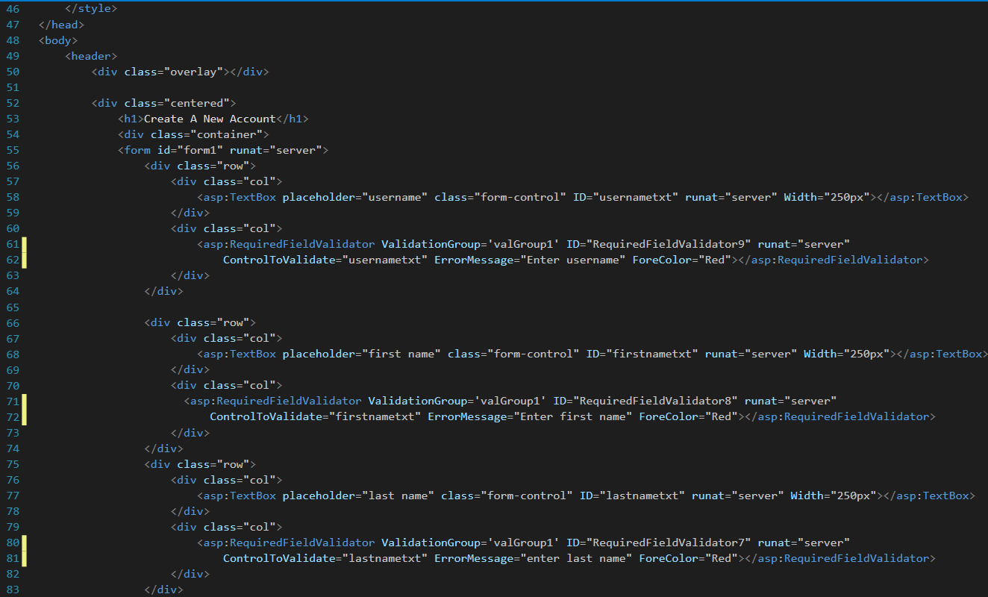

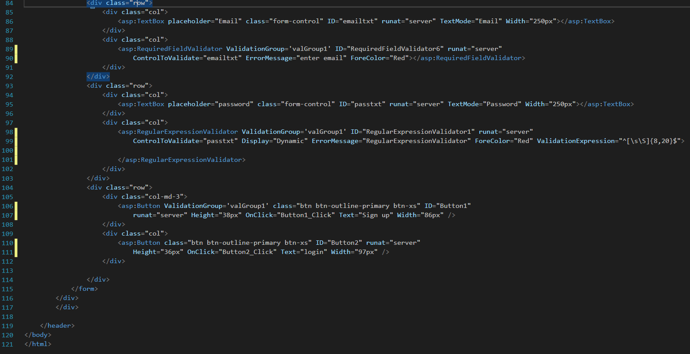

**Register page server side:**

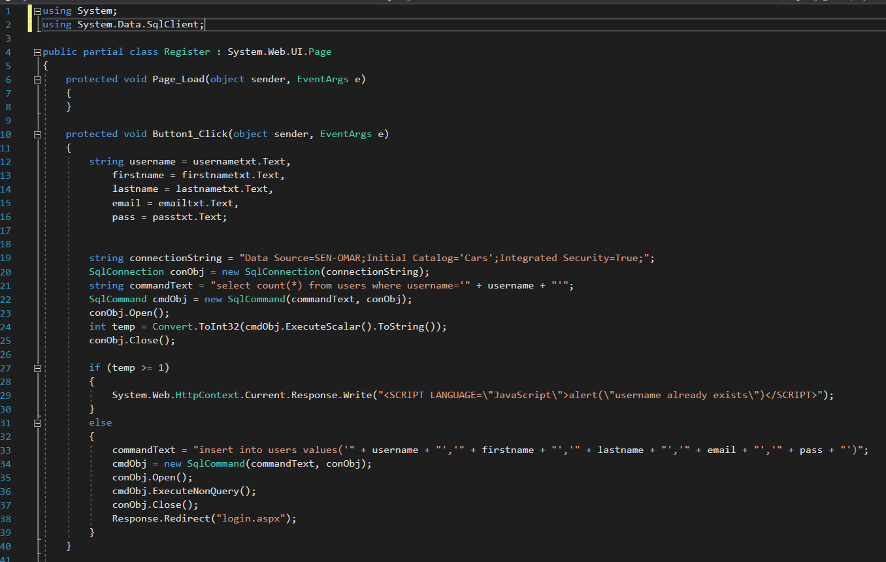

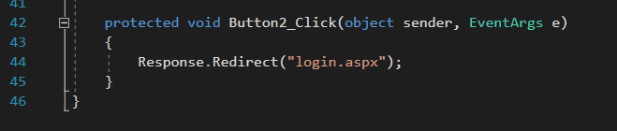

**Login Page Client Side:(Html &css Side with some asp.net)**

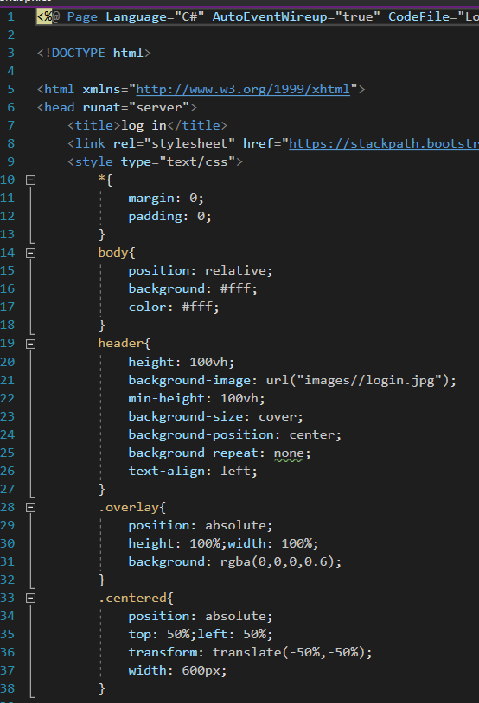

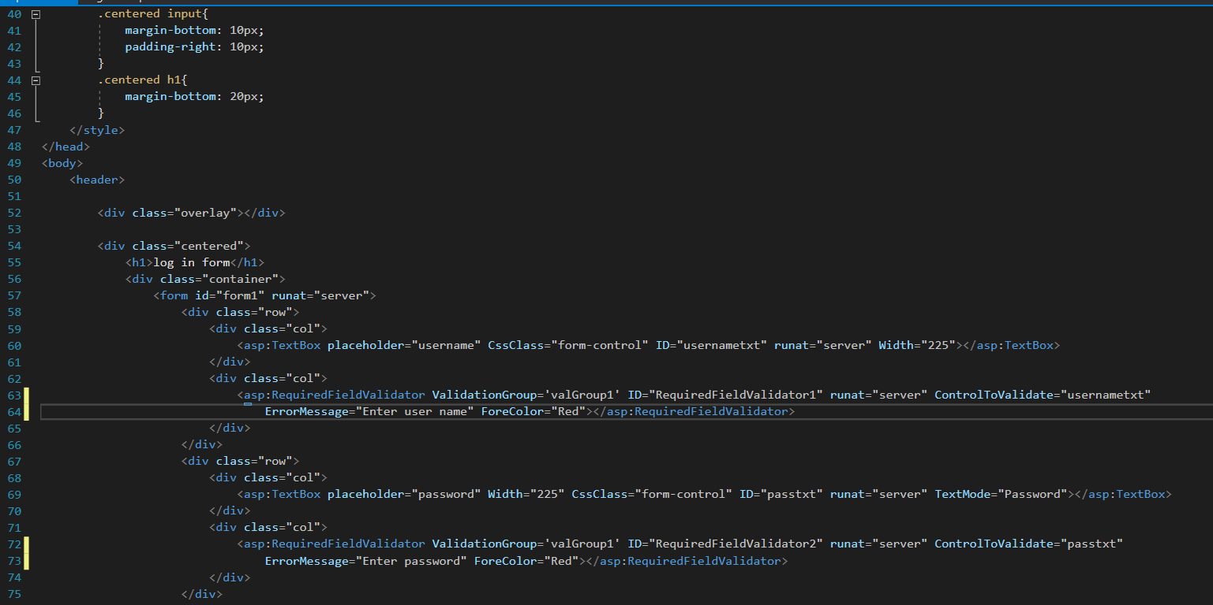 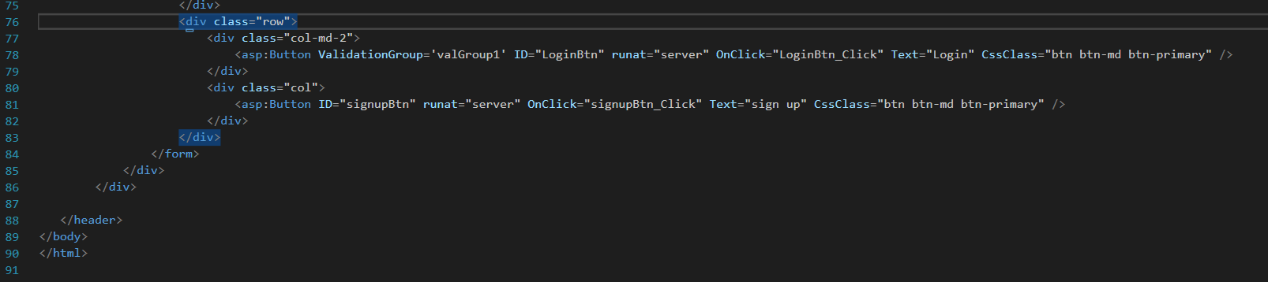

**Login page server side:**

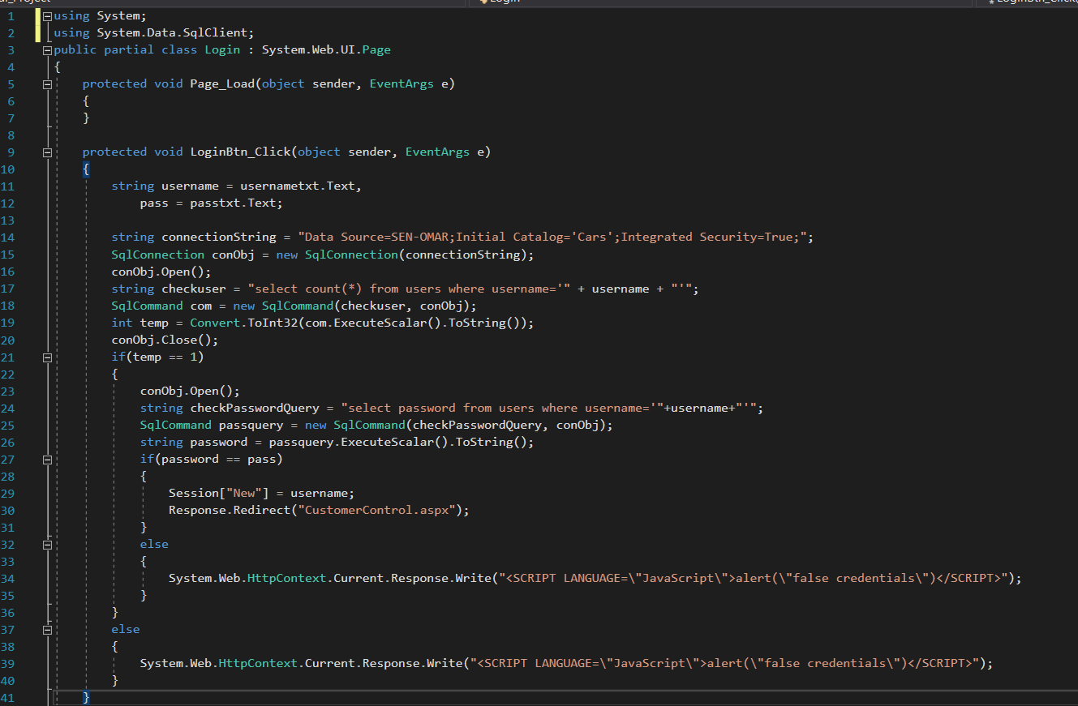

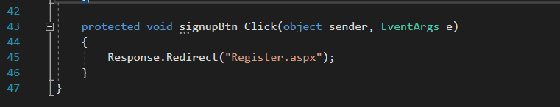

**CustomerControl Page Client Side:(Html &css Side with some asp.net)**

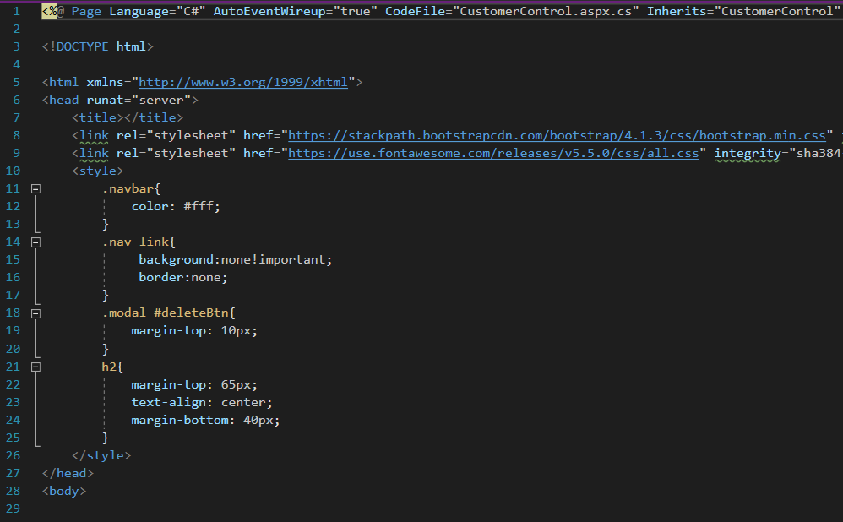 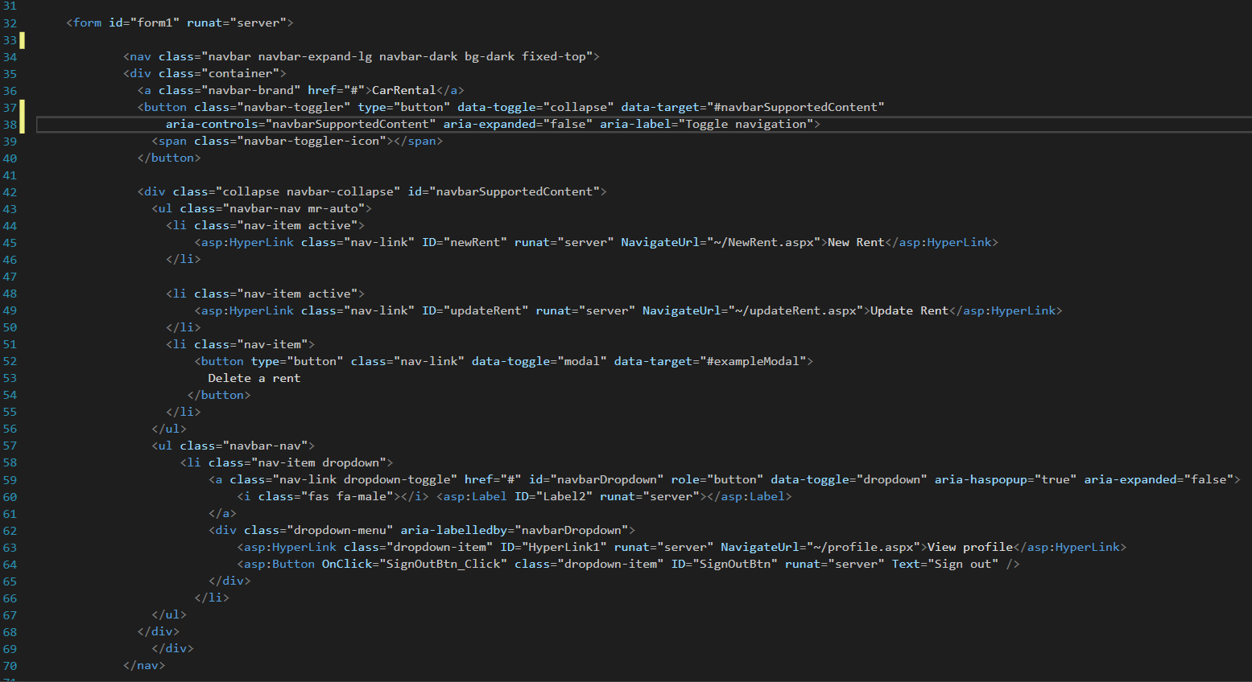

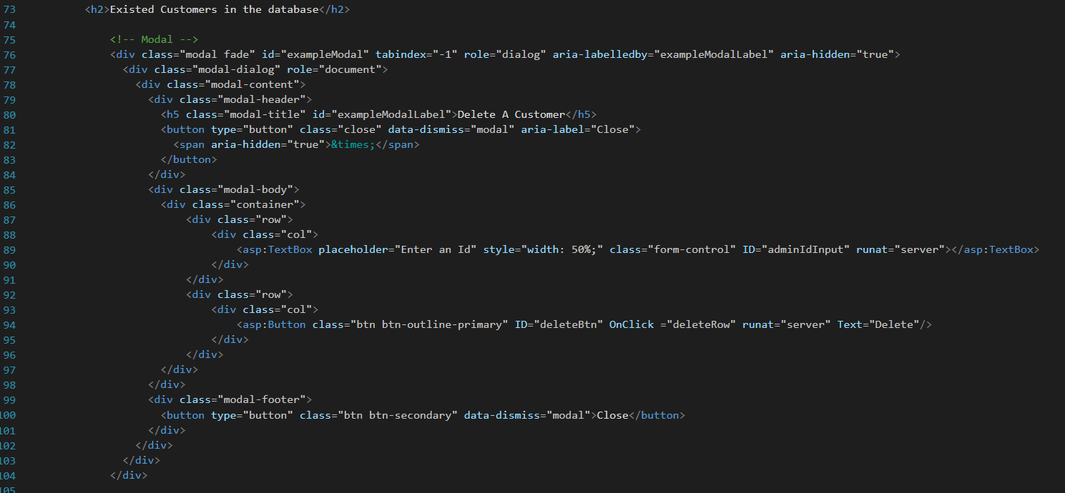 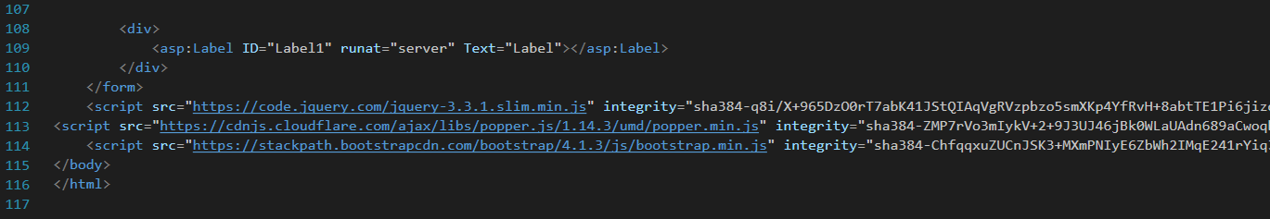

**Customer Control page server side:**

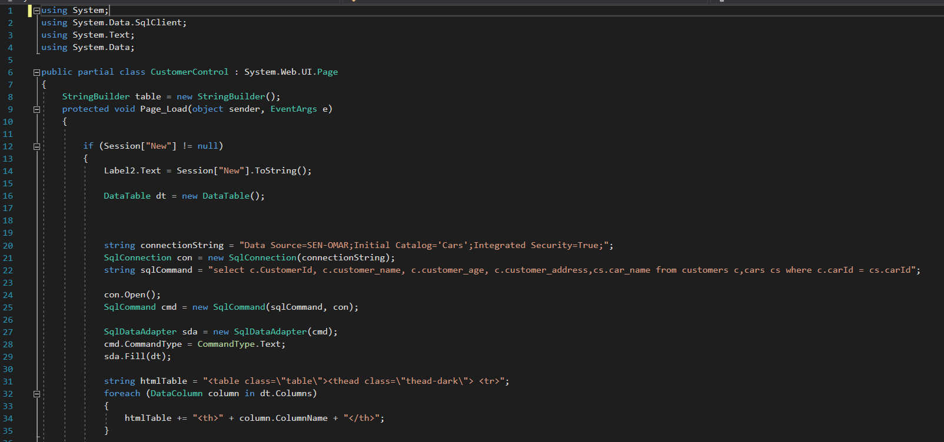

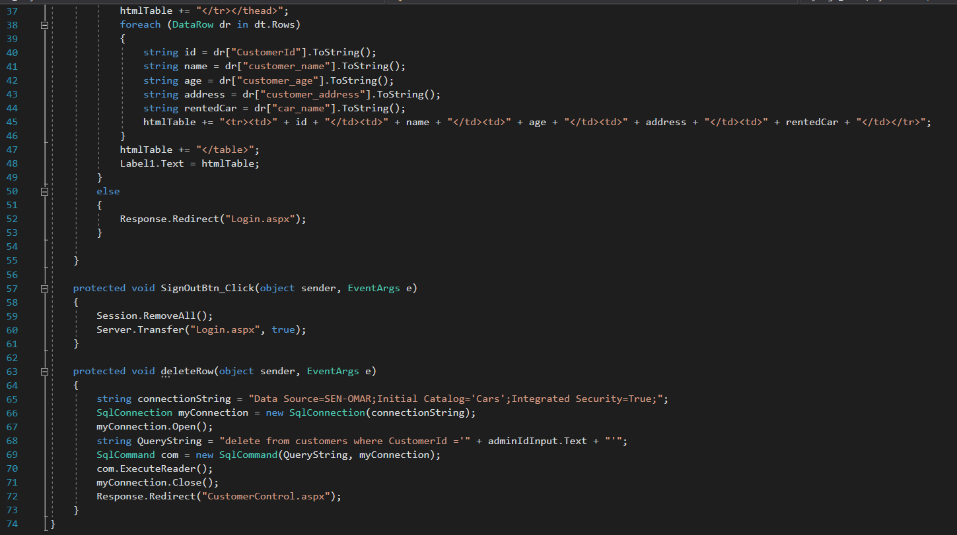

**NewRent Page Client Side:(Html &css Side with some asp.net)**

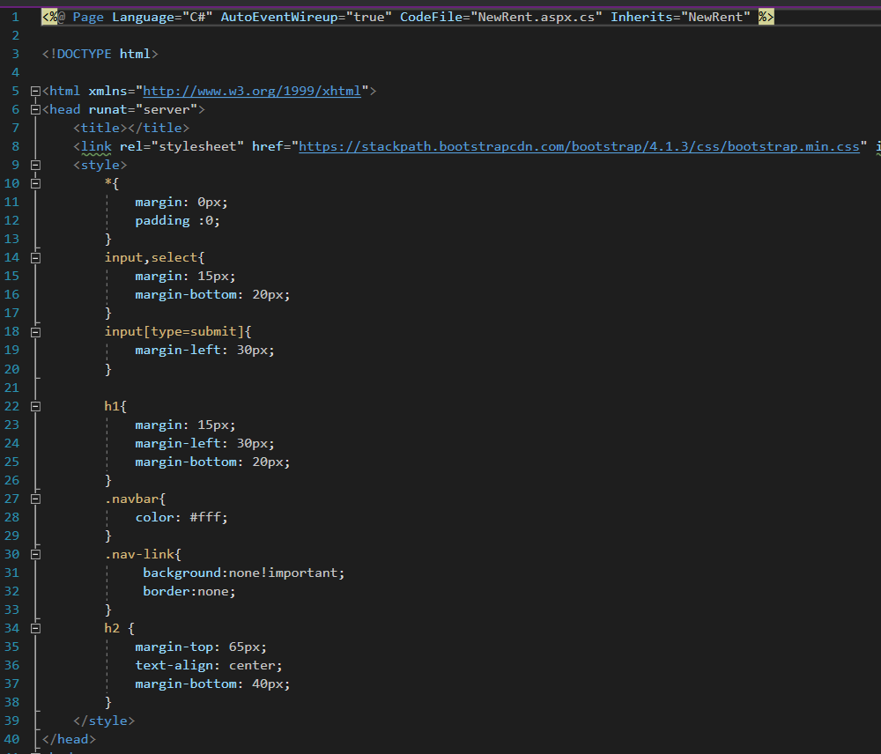

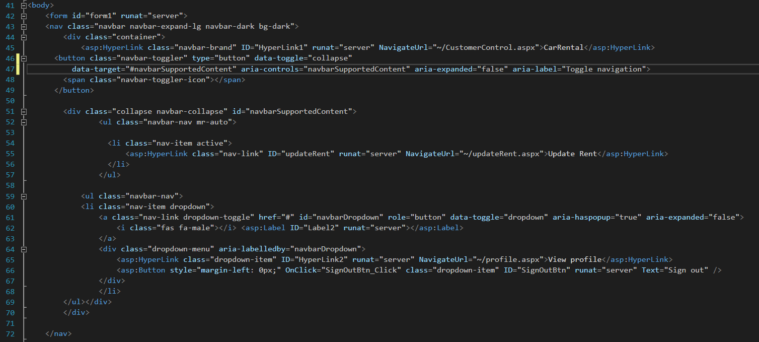 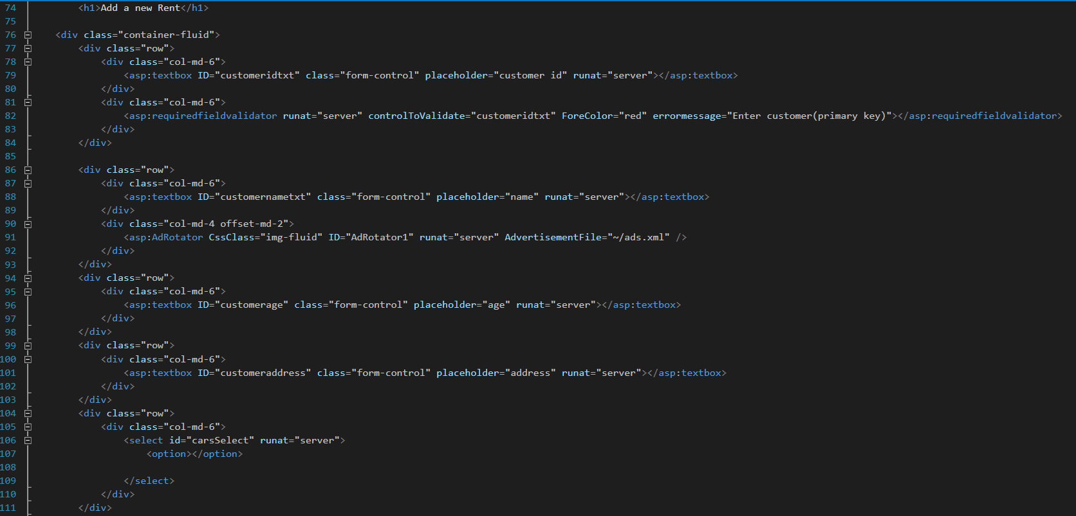 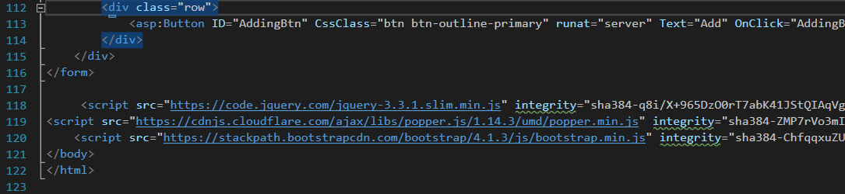

**NewRent page server side:**

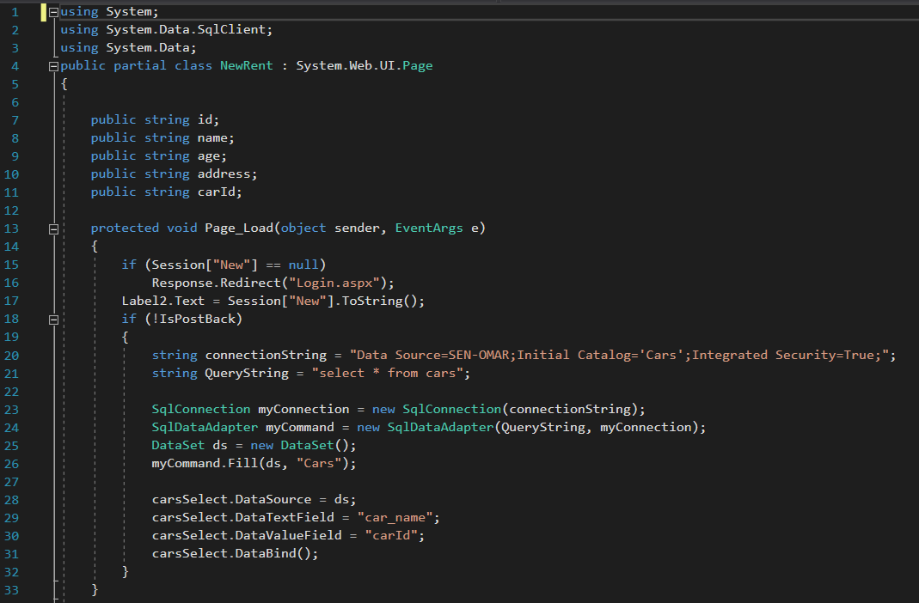 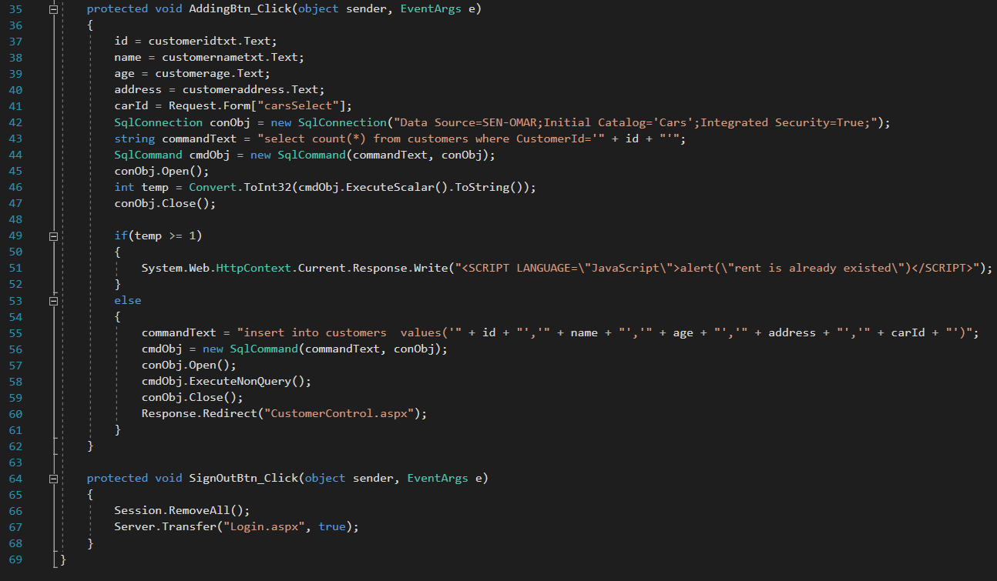

**Update Rent Page Client Side:(Html &css Side with some asp.net)**

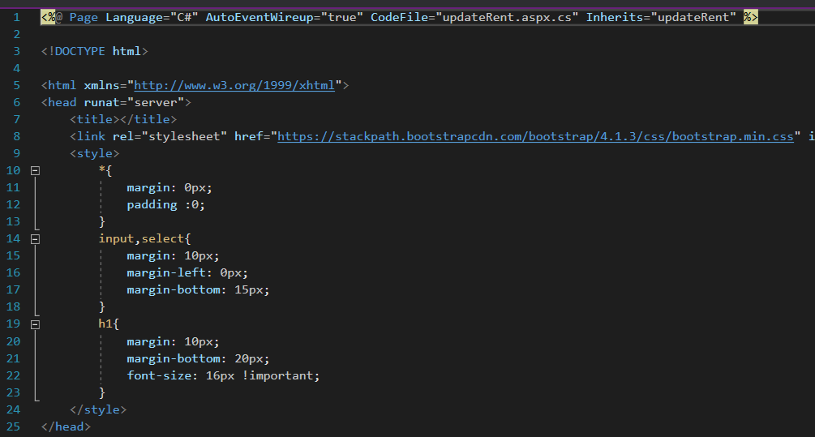 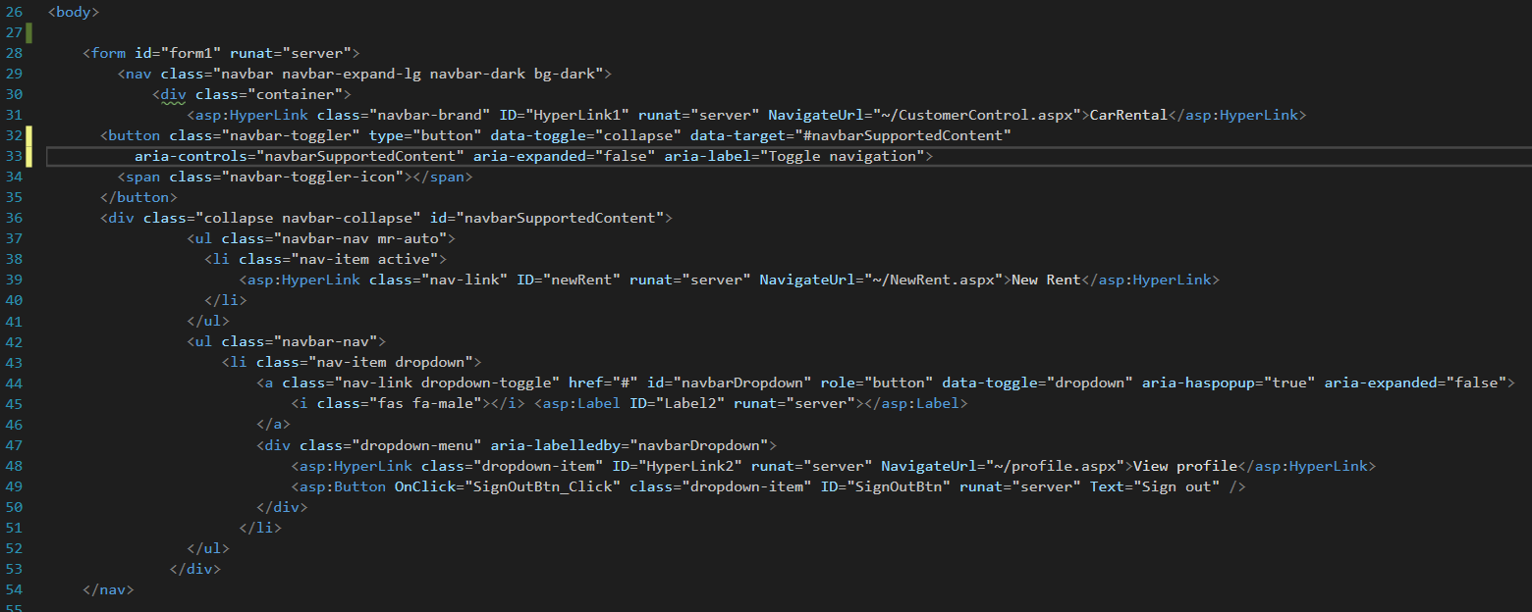

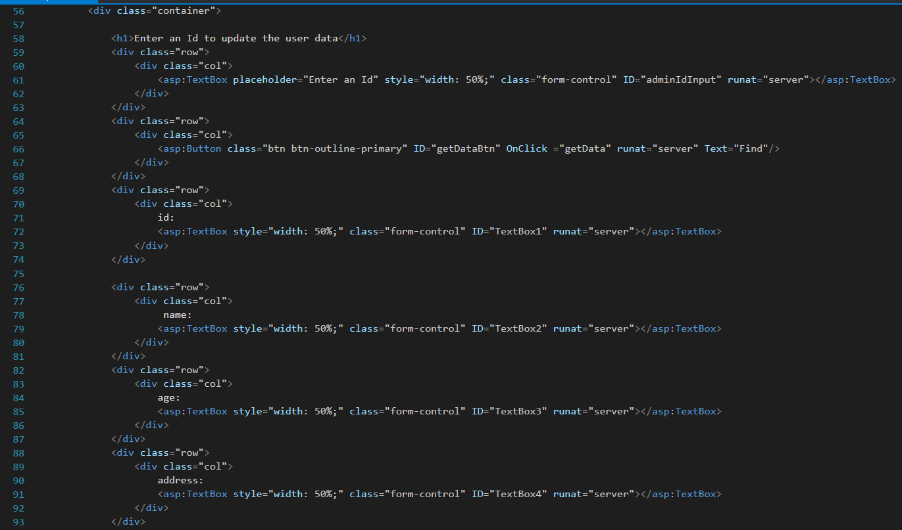

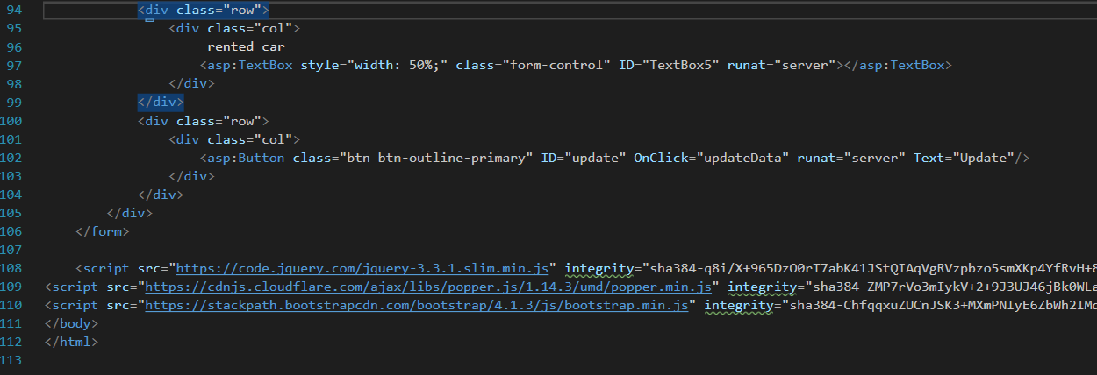

**Update Rent page server side:**

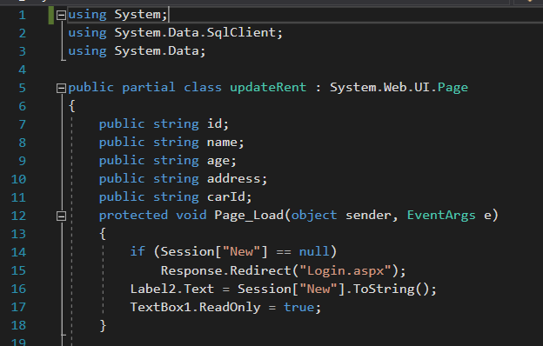 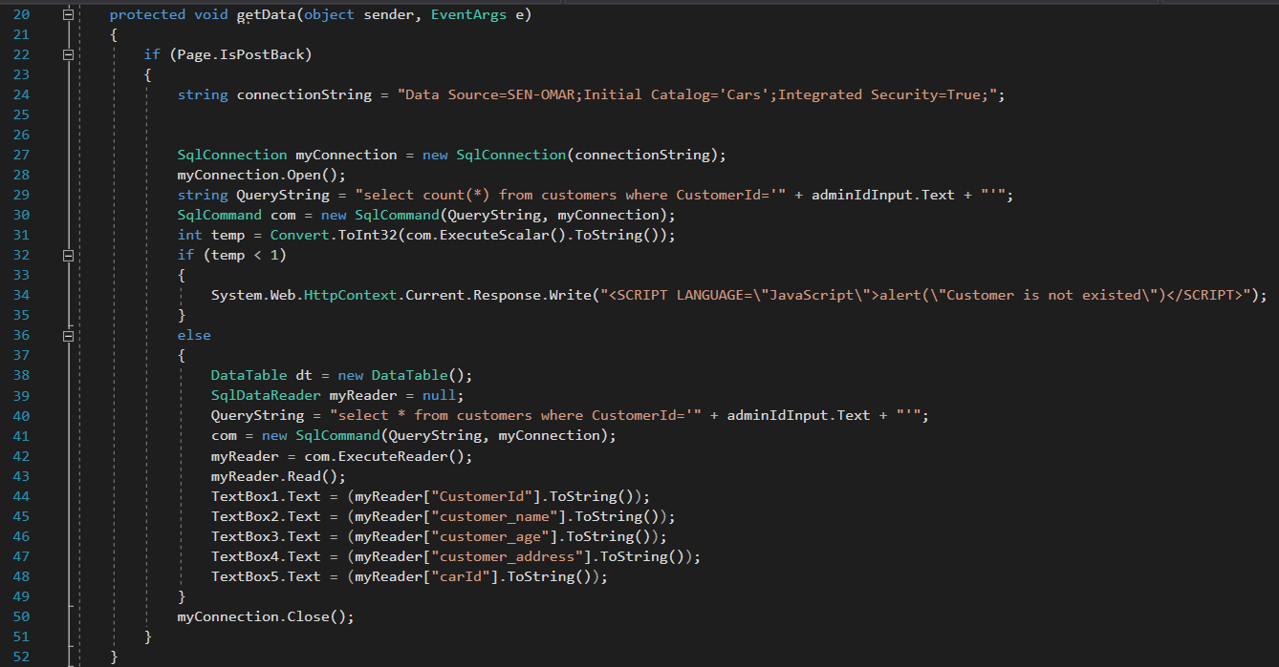

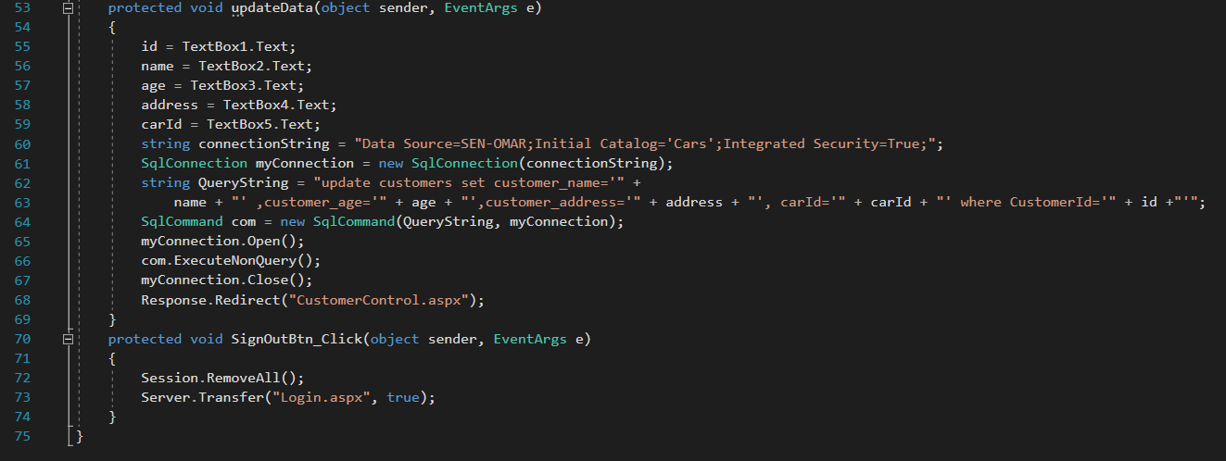

**View Profile Page Client Side:(Html &css Side with some asp.net)**

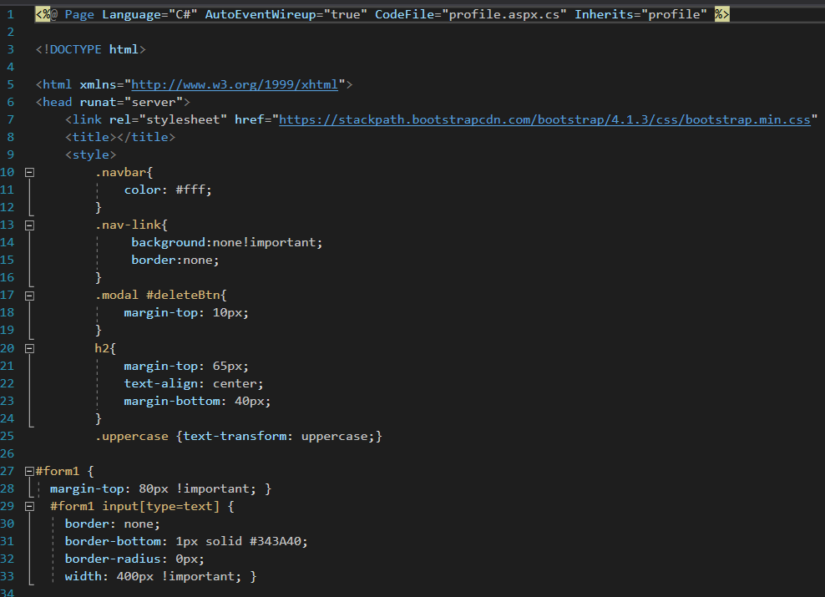

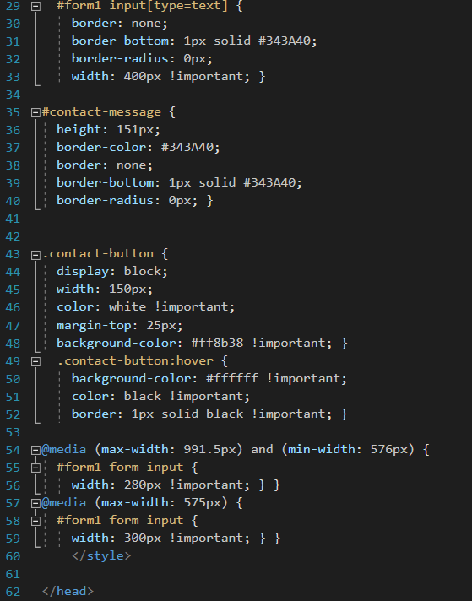

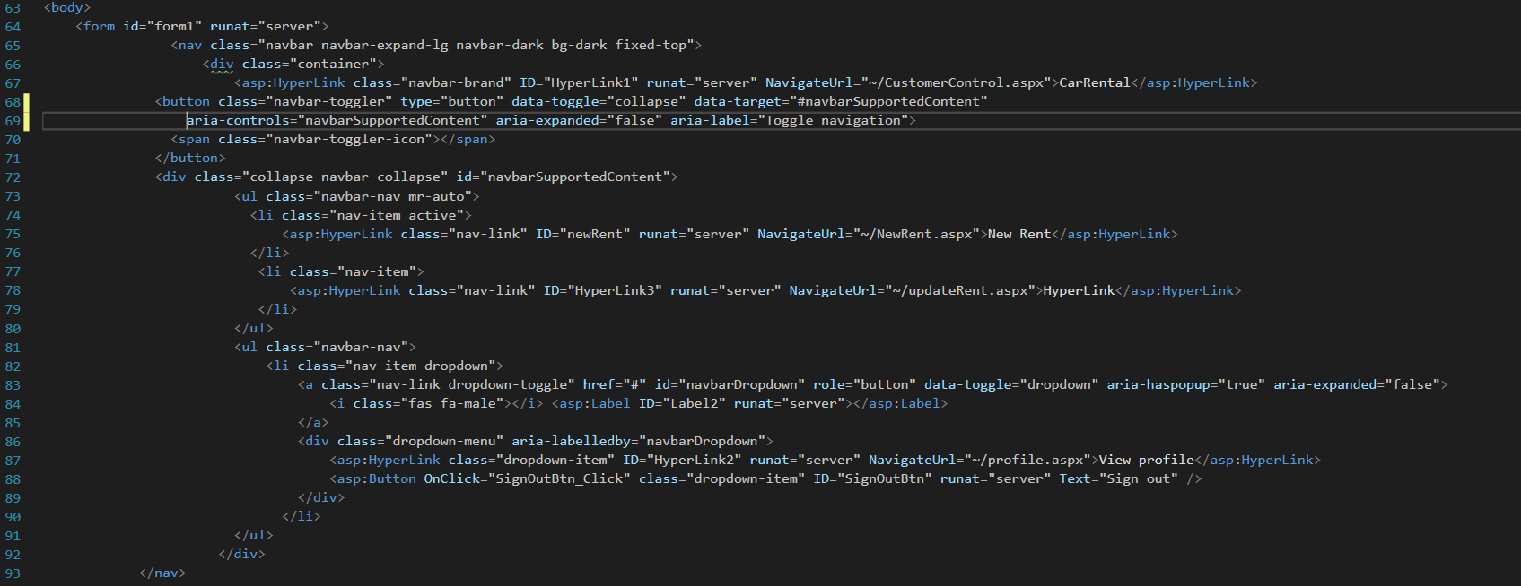

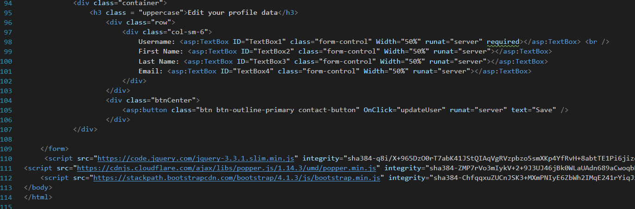

**View Profile page server side:**

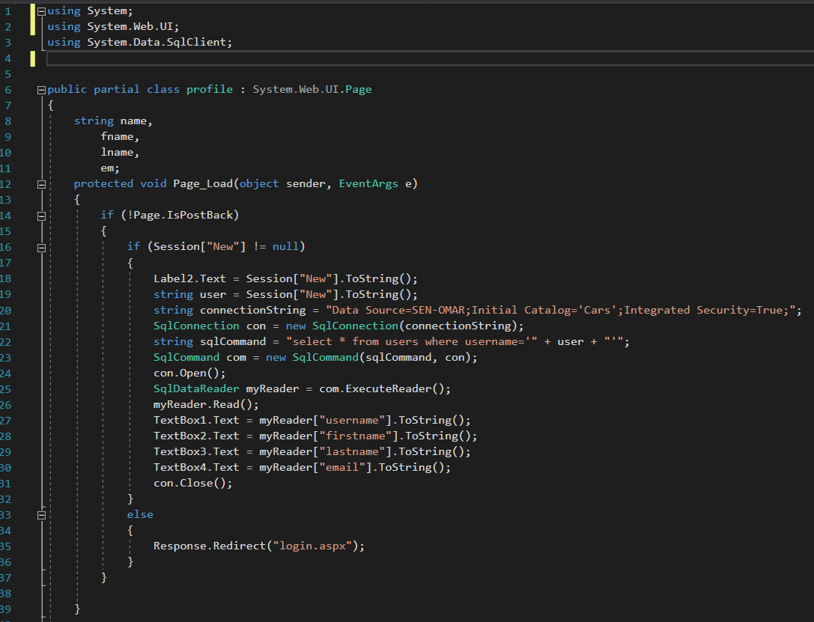

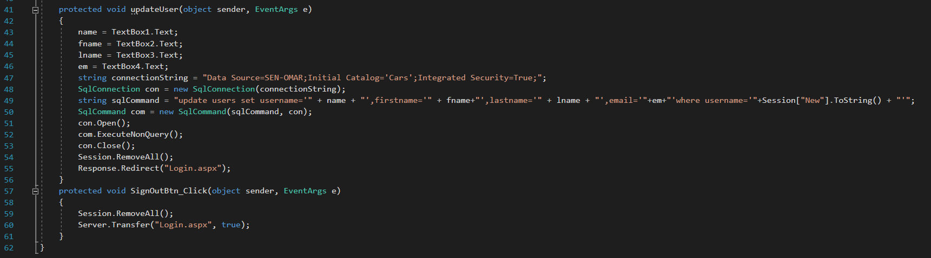

**Output:**

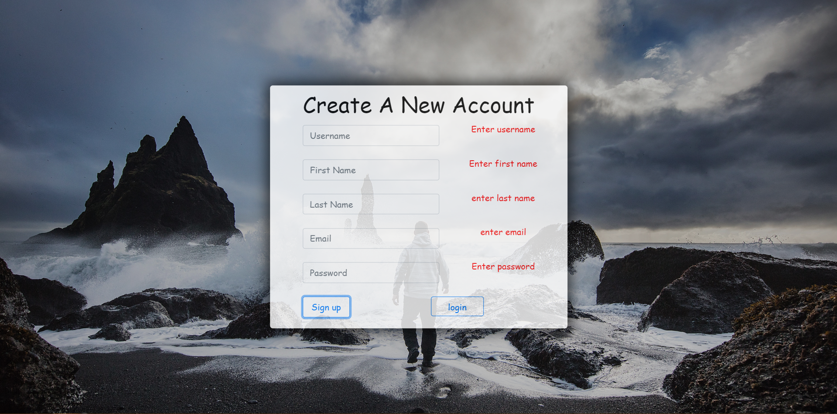

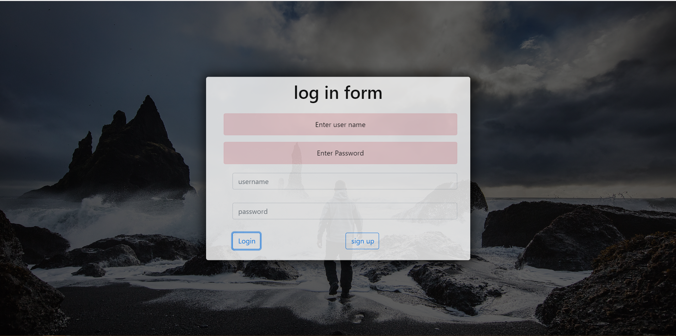

**After loggin in:**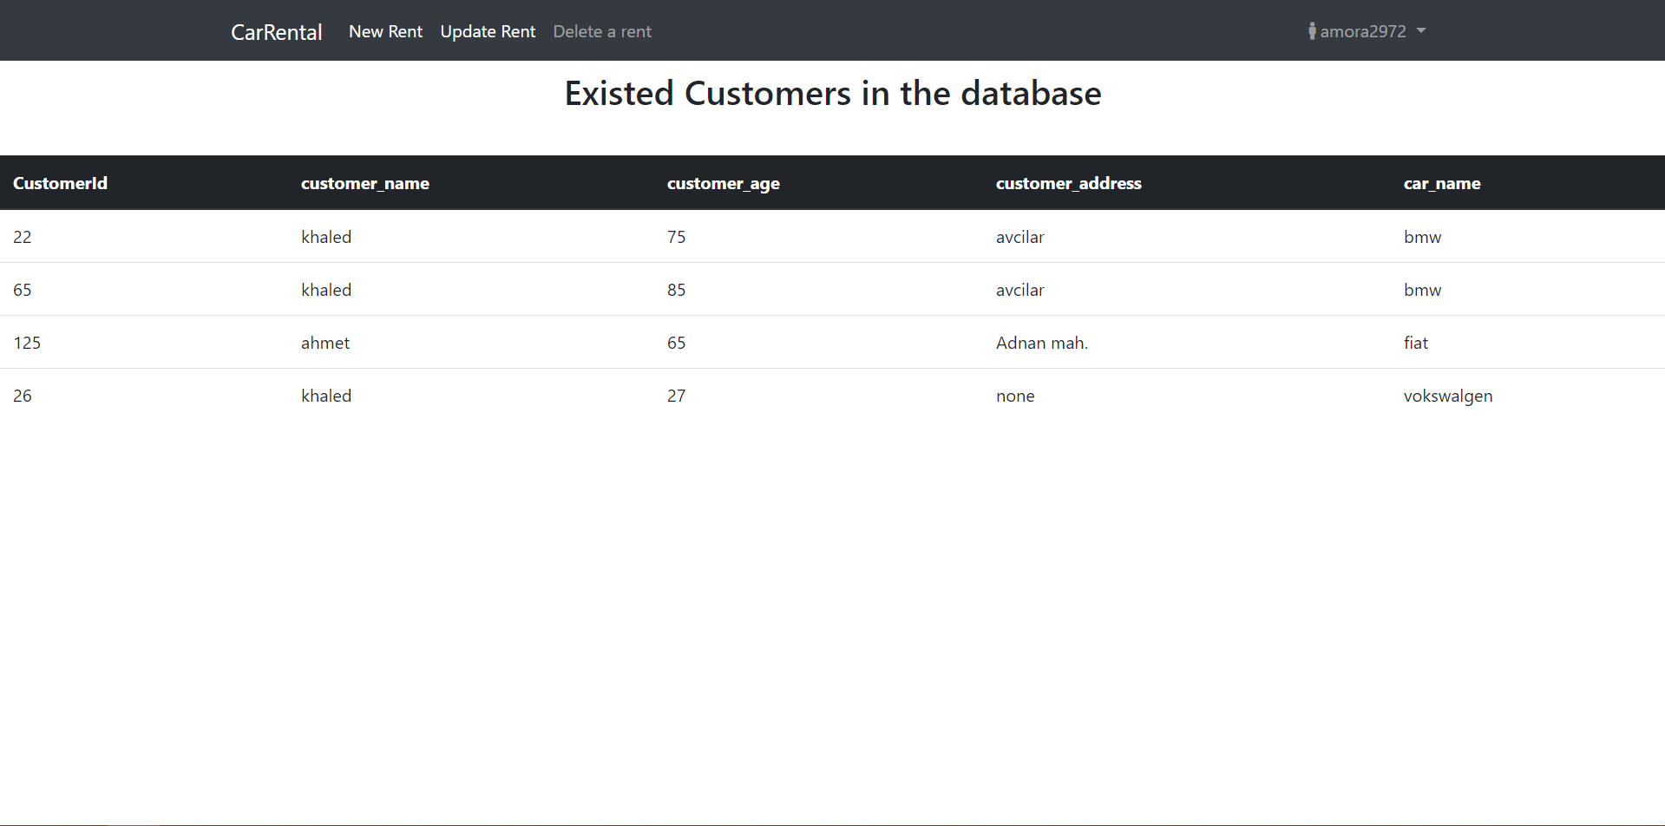

**New rent**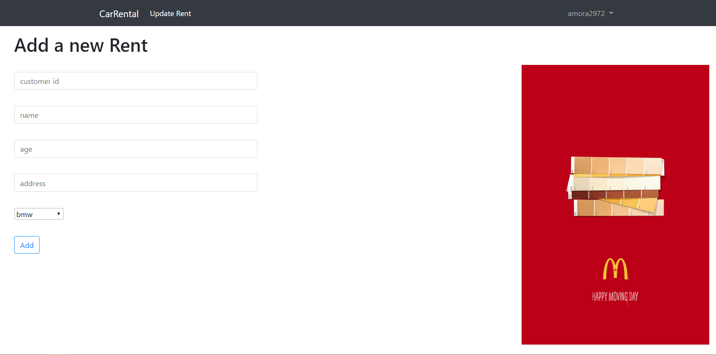

**Update rent:**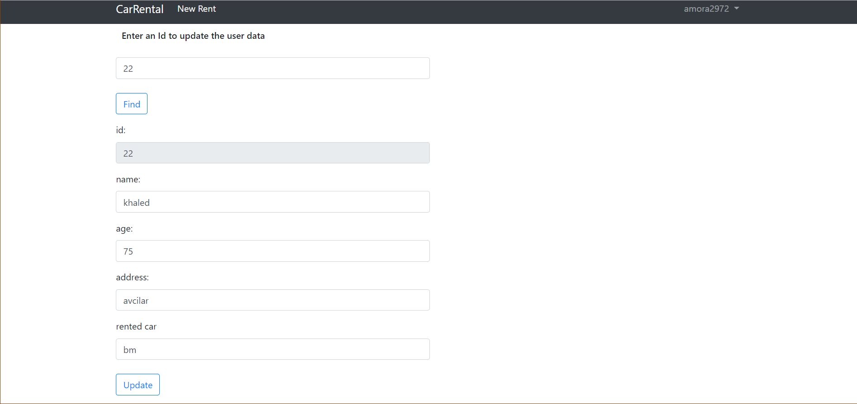

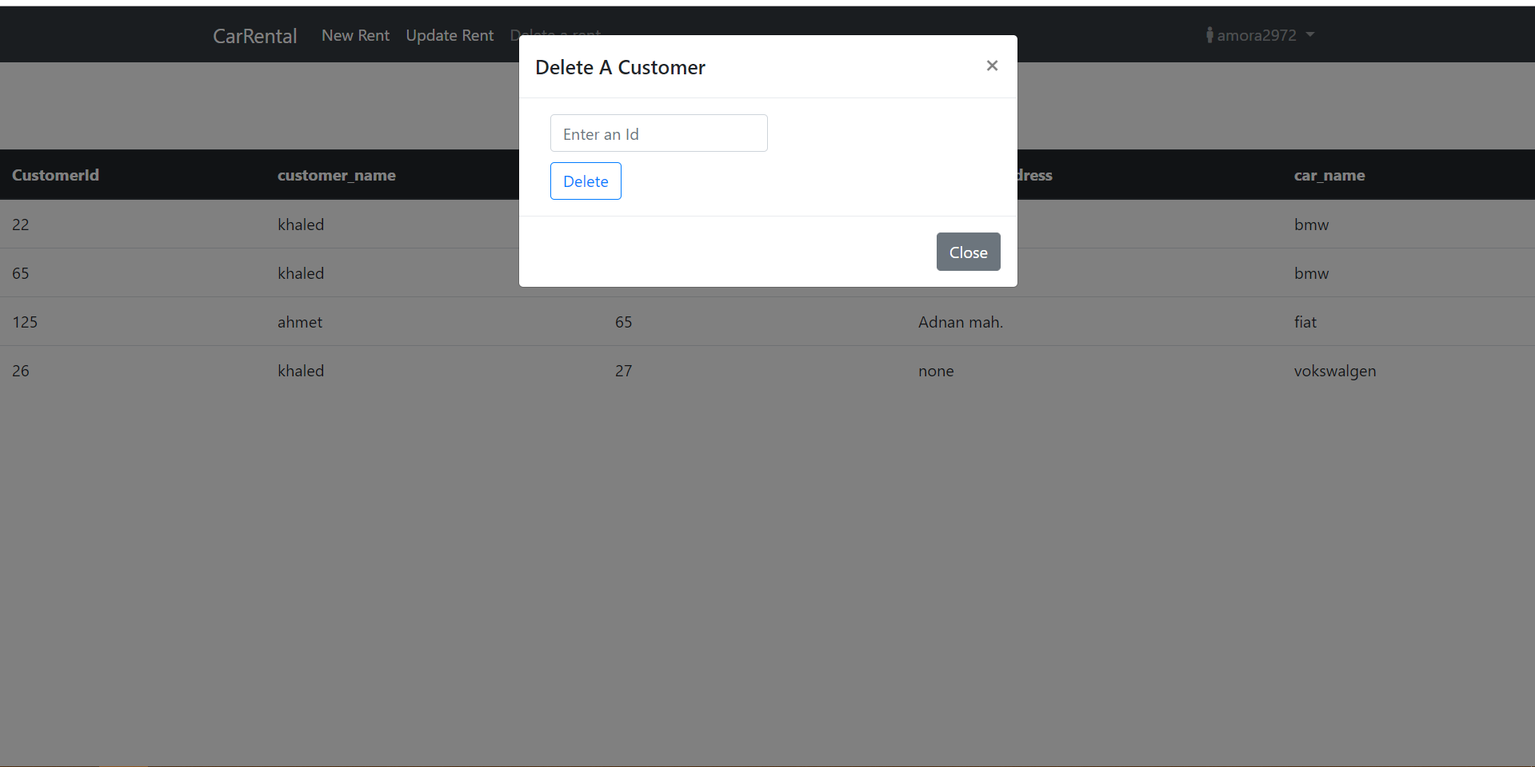

**Edit profile**